Re-Surface

Group Show: October 1 – November 13, 2022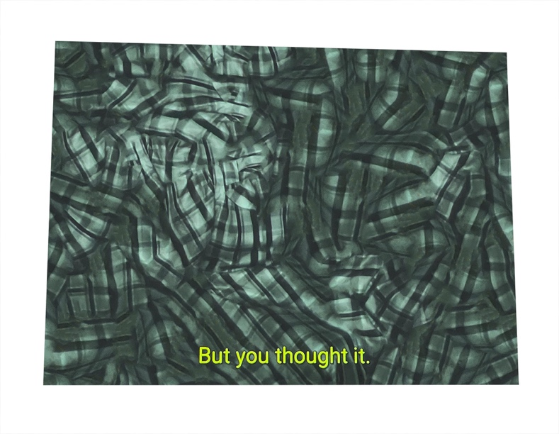
The Fulcrum Press is pleased to present Re-Surface, an exhibition of works by Sara Greenberger Rafferty, Vincent Ramos, Brandon Lattu, Asha Schechter, Heather Rasmussen, and Suzanna Zak.
Photography today occupies an intersection between the rapid proliferation and advancement of digital technologies, and the gradual extinction of analog media, a state that has made inevitable the dislodging of conventionally expected outcomes. The works in the exhibition operate within shifting relationships to their own materiality, recontextualizing the original photographic gesture within medium, time, and functionality. Here, the photographic image serves as witness to the act of mediation, pointing back to itself via both medium and subject matter.
The archive emerges as a throughline between the works, appearing alternately as historical index, as personal record of time, as body, as commercial fabrication. Contrasted with its contemporary presentation, the tells of the historic medium serve as a lens through which to enter the embedded histories and to index alternate utilitarian potentialities within each work.
Once an image has satisfied the parameters of its original intent, it becomes subject for re- examination and repurposing, determined by its new context. Within that process of being re- filtered through practices of critical examination and mechanical reproduction, something uncanny happens as the image carries these artifacts from one destination to the next.

